Installation of Code Composer Studio 5

1. Navigate on CCS5 webpage: <http://www.ti.com/tool/ccstudio> . Click “Order Now” button and the page will redirect you to a table. From that table select to download “CSS-FREE”.

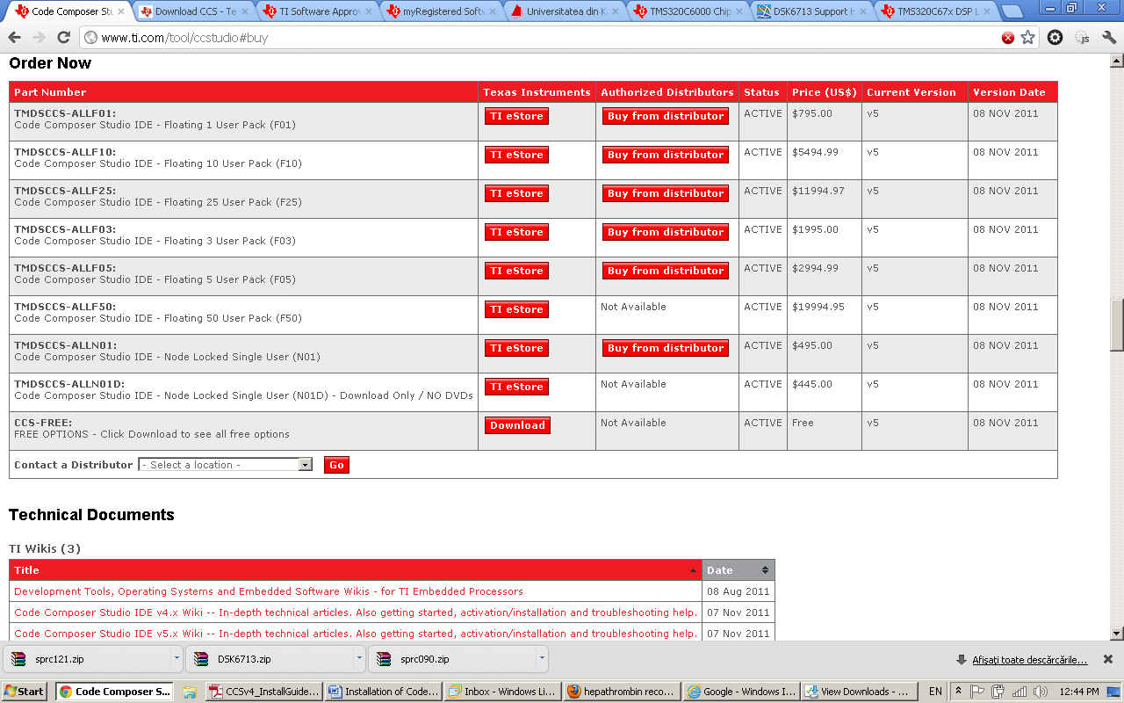

* 1. You will be redirected to <http://processors.wiki.ti.com/index.php/Download_CCS> which is the page where CCS Repository is listed. Select the latest version (5.2.0 so far) by clicking on “Off-line installers”, Windows link (if you want to install on Windows Operating System).

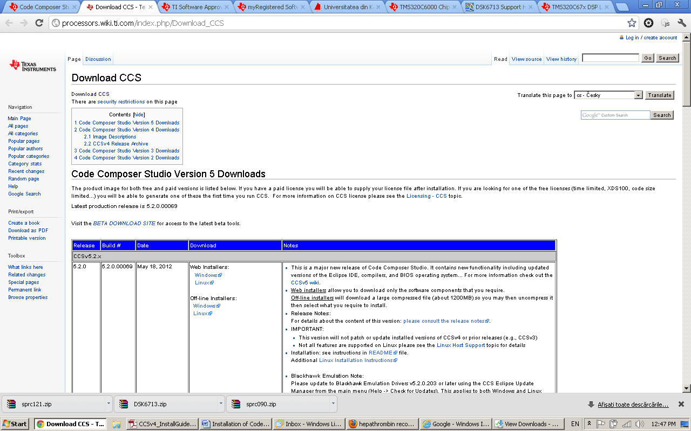

* 1. You will be asked to register for free. Complete the form, valid email address will be necessary and then click “Register and Continue”. You will be asked to complete another form, in completion for the first, in which you’ll describe briefly the use of the software, accept the terms and click “Continue”. When registration is complete the download is ready. By pressing the “Download” button on the page proceeding final registration an 1.2GB archive with name “CCS5.2.0.00069_win32.zip” will start downloading (this includes CCS5 software offline installation package).

1. Extract “CCS5.2.0.00069_win32.zip” and after extraction is complete, run the executable “ccs_setup_5.2.0.00069.exe” which can be found in the extraction folder.
2. Proceed installation as following:
   1. Accept license, hit next

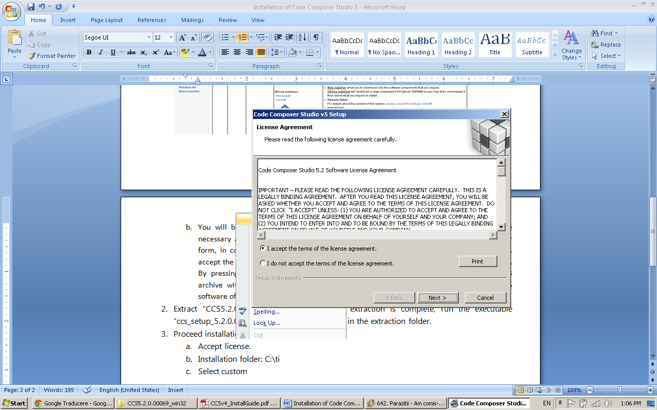

* 1. Installation folder: “C:\ti”, leave it default, hit next

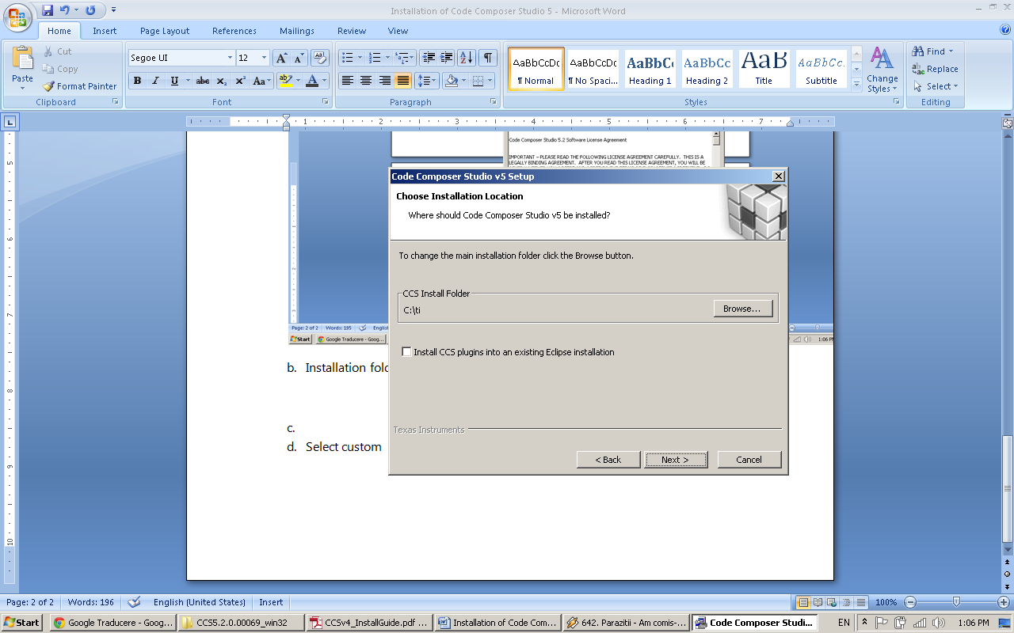

* 1. Select custom setup, hit next

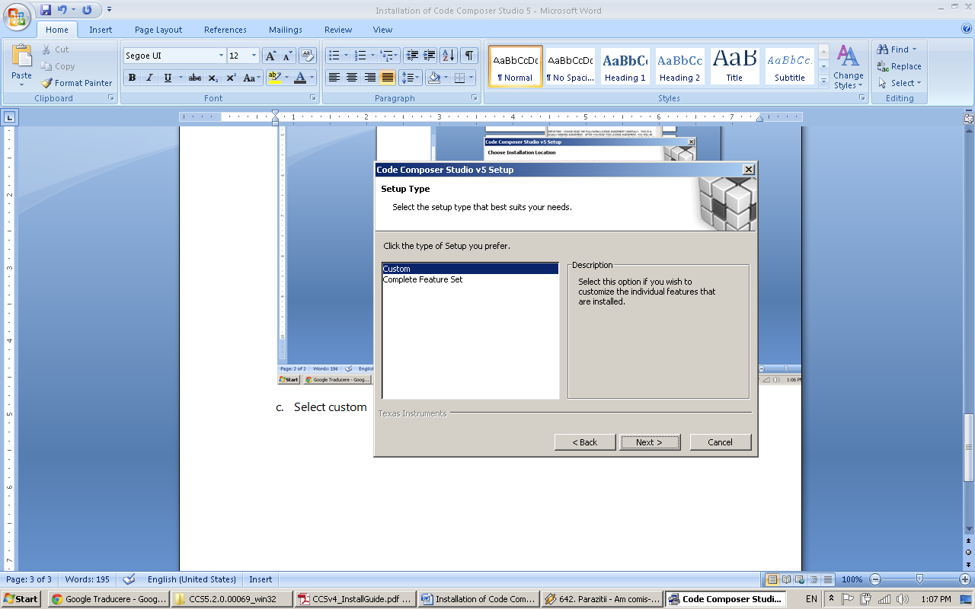

* 1. Select from the list C6000 DSPs Single Core (at least). Optionally you can select more architectures but this will slow the installation by downloading more data

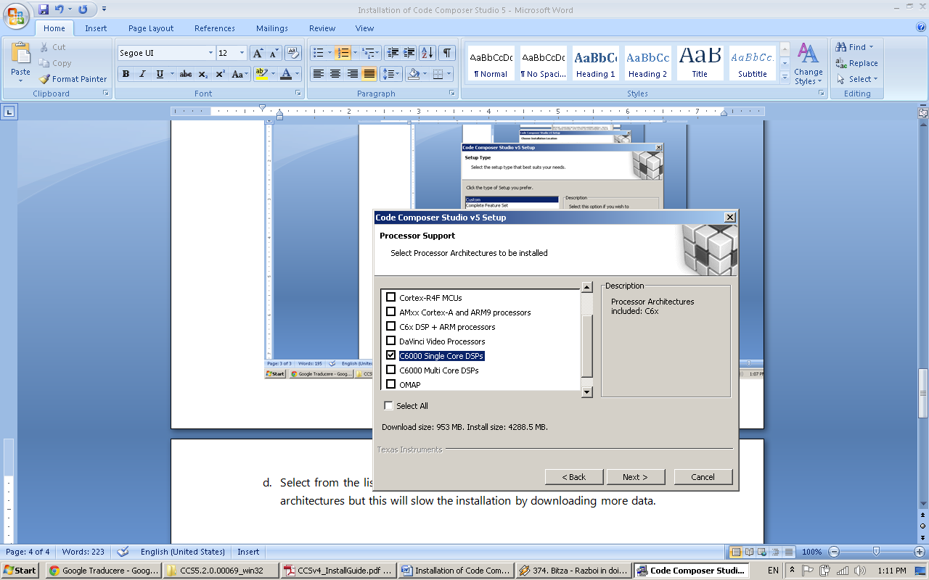

* 1. Ensure all components are selected (selected by default), hit next

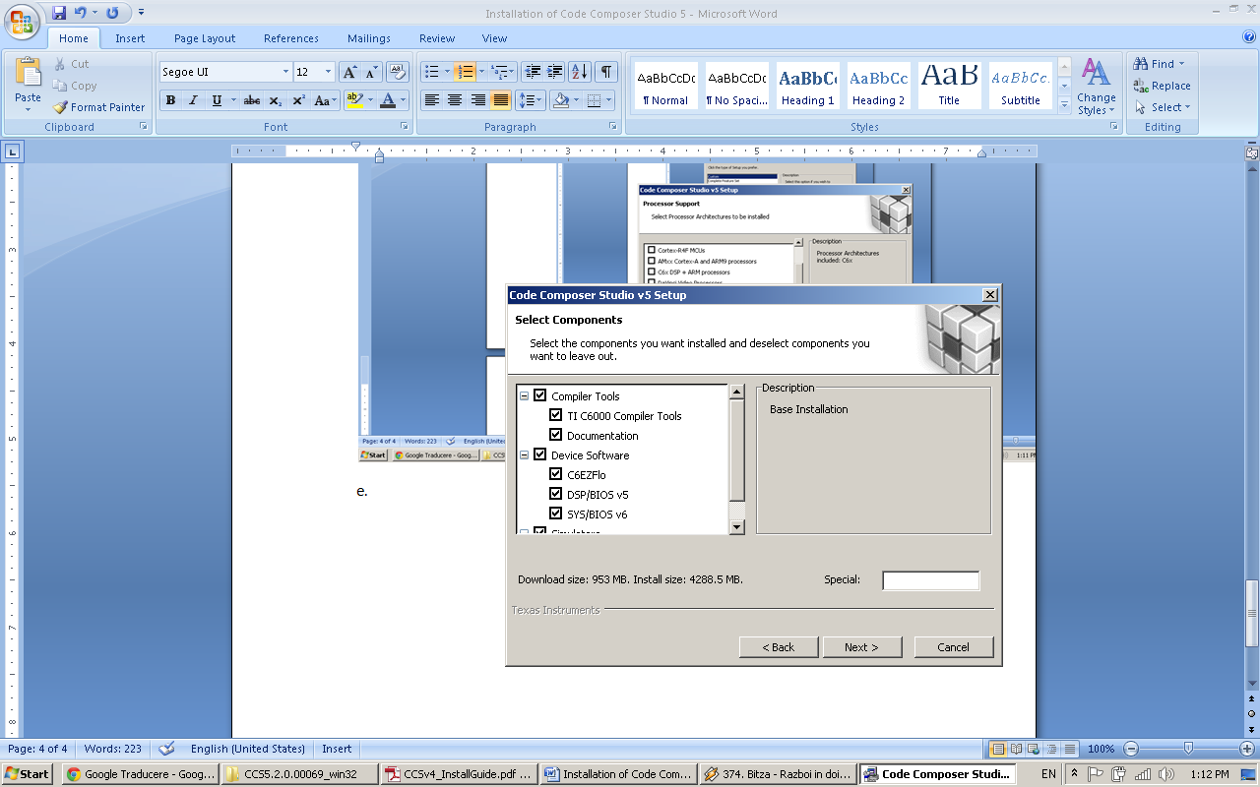

* 1. Emulator selection leave it default, hit next

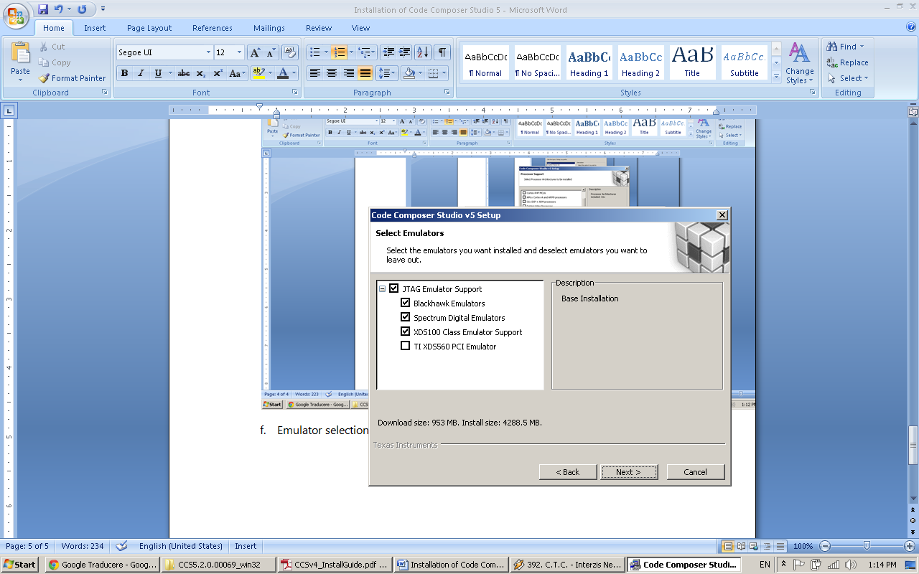

* 1. Installation information will appear, hit next to start installing product

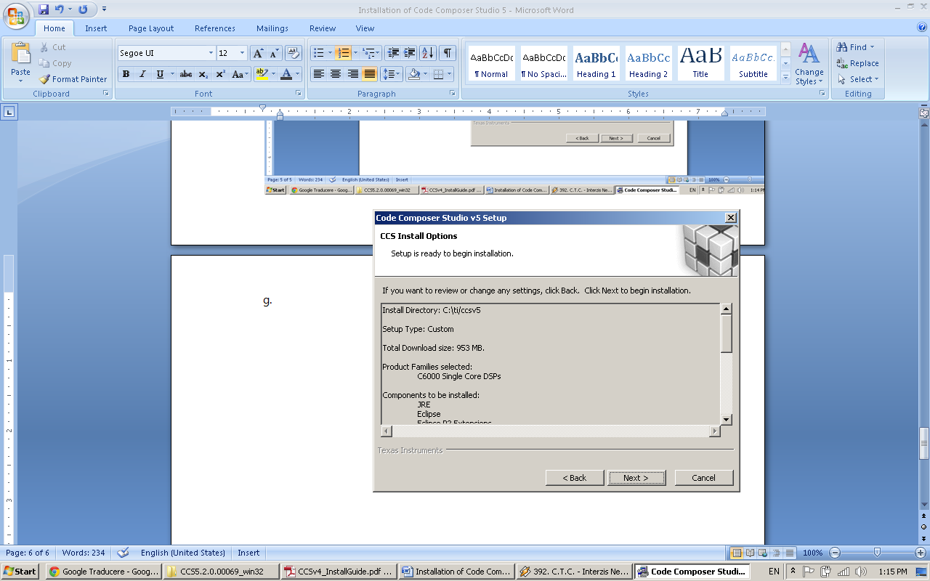

* 1. Even if installer is offline it will download DSPs architecture libraries from the internet, as result make sure you are connected to internet during installation.
  2. Installation finished, launch CCS5 automatically by checking “Launch Code Compose Studio 5” and hit Finish.

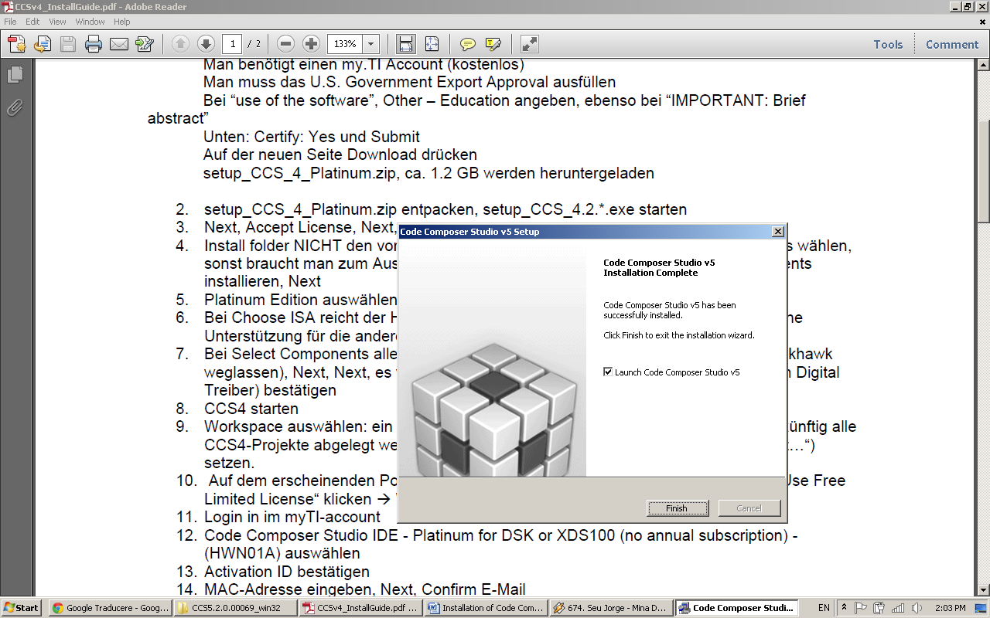

1. When you’ll be asked for workspace, hit ok for default setup.

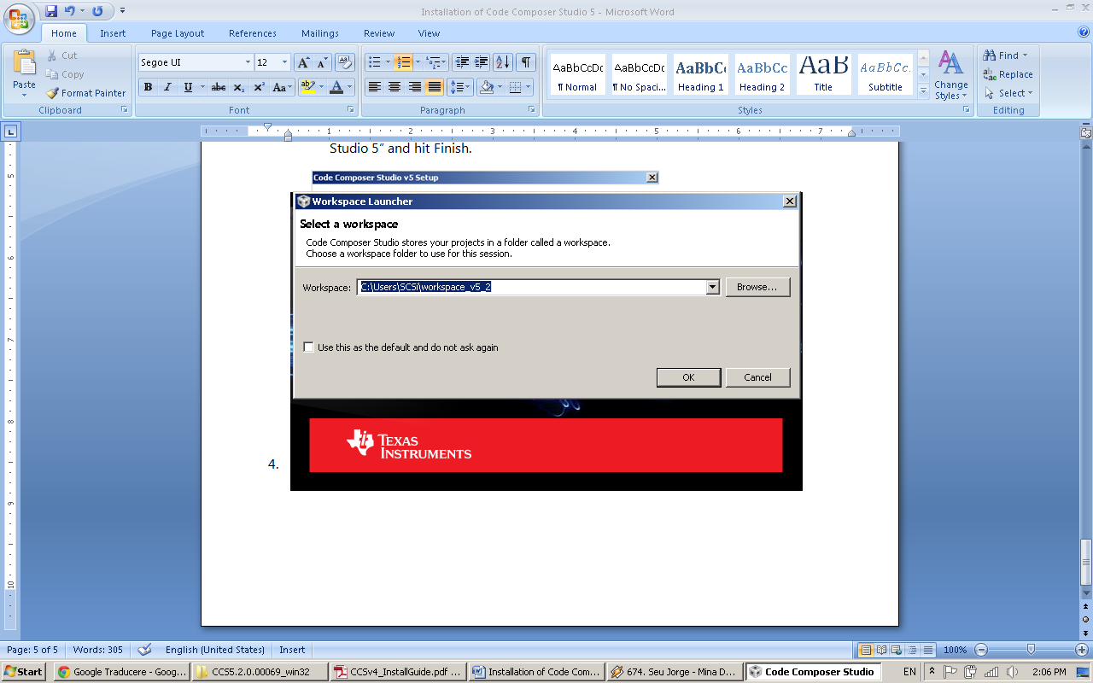

1. When the application will start, you will be asked for License, check “FREE LICENSE” then click “Finish”.

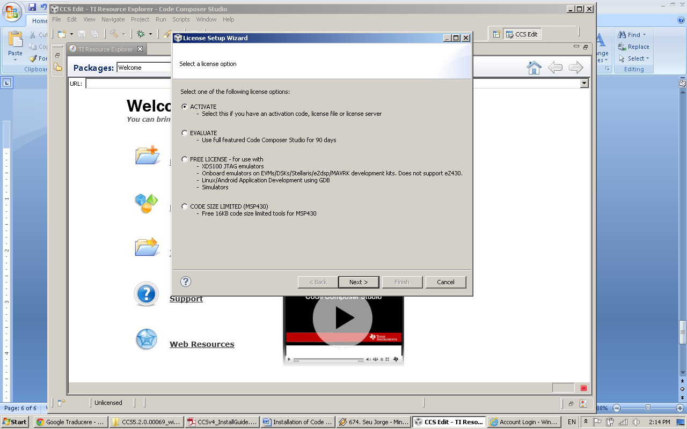

1. Code Composer Studio 5 is now installed.

Installation of Chip Support Library (CSL)

1. Download CSL (file named “sprc090.zip”) from <http://focus.ti.com/docs/toolsw/folders/print/sprc090.html>
2. Extract “sprc090.zip” (2MB) and run “C6000.exe” from extraction folder.
3. Proceed setup and when asked for installation directory, set “**C:\ti\**C6xCSL”, with bold is indicated installation directory for CCS5.
4. Complete installation by hitting “Next” button leaving default options on the rest of wizard pages.

Board Support Library Installation (BSL)

1. Download BSL (file named “DSK6713.zip”) from <http://c6000.spectrumdigital.com/dsk6713/>
2. Extract “DSK6713.zip” (16MB)
3. Copy entire extracted folder named “DSK6713” into “**C:\ti\”** the installation folder of CCS 5.
4. BSL location is **C:\ti\**DSK6713\c6000\dsk6713\lib\dsk6713bsl.lib

Installation of DSPLIB

1. Download DSPLIB (file named “sprc121.zip”) from <http://focus.ti.com/docs/toolsw/folders/print/sprc121.html>
2. Extract “sprc121.zip” (1.2MB) and run “C67xDSPLIB_v200.exe” from extraction folder.
3. Proceed setup and when asked for installation directory, set “**C:\ti\**CCStudio”, with bold is indicated installation directory for CCS5.
4. Complete installation by hitting “Next” button leaving default options on the rest of wizard pages.
5. DSPLIB location is “**C:\ti**\CCStudio\c6700\dsplib\lib”